Dr Sani & Partners
This Photo by Unknown Author is licensed under CC BY-SA

As of Thursday 28th March 2024, the POD is closing. You will now need to use either of the following to order your prescriptions.

- Via the NHS APP - if you do not have access request this from reception but you must provide 2 forms of ID; photo and address.
- Use our email address – cwicb.sani-info@nhs.net
- Through our website’s contact us page – www.Dr SaniandPartners.nhs.uk
- Hand in a slip at our reception desk – please use the right-hand side of your prescription and tick off everything you need.
- By telephone for our vulnerable patients who are unable to use any of the above to call 02475 261996 Option 2 only between 10.30am – 2.00pm

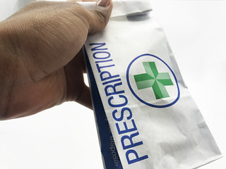
ALLOW 48 HOURS FOR YOUR PRESCRIPTION TO BE PROCESSED
This Photo by Unknown Author is licensed under CC BY

